1. Go to: <https://cygwin.com/install.html>
2. Click Install Cygwin

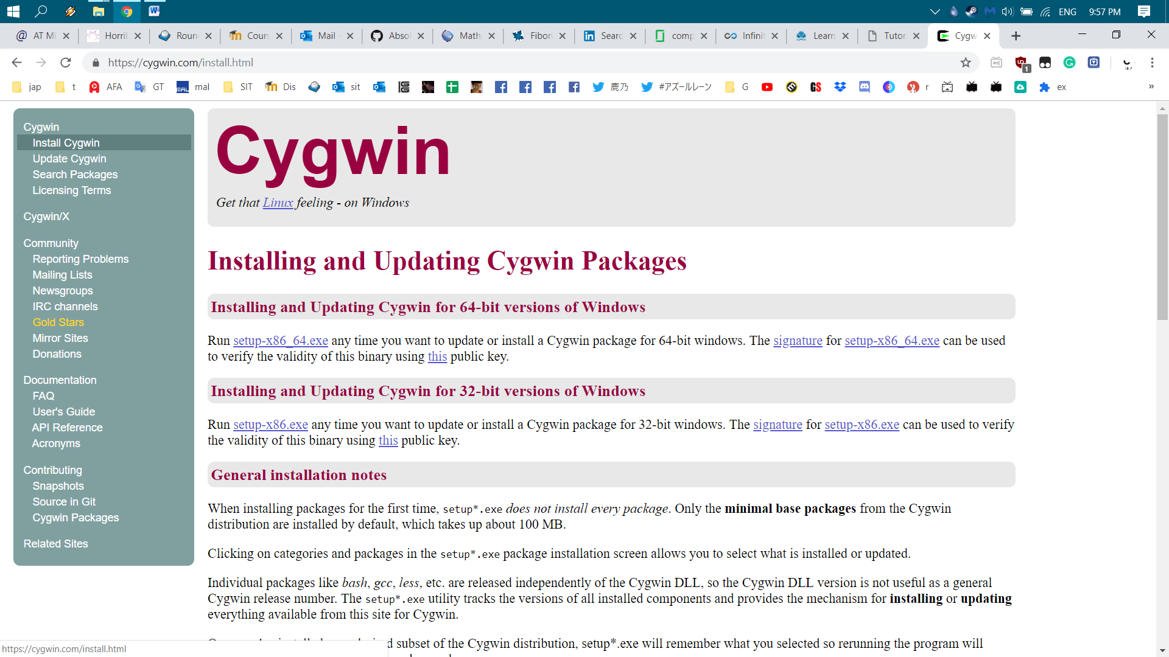

1. Download either setup-x86_x64.exe for 64-bit version or setup-x86.exe for 32-bit version

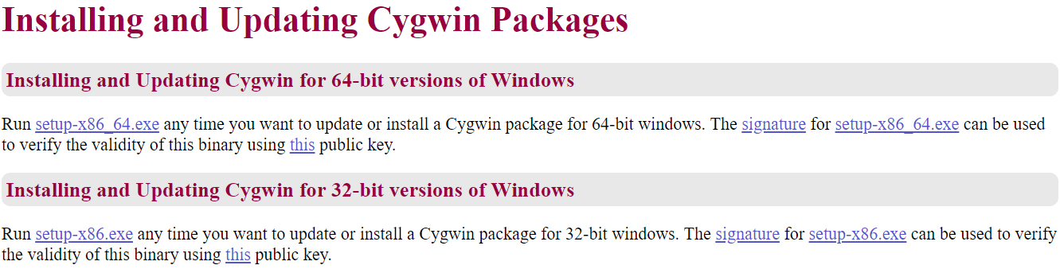

1. After downloaded, double click to run and see the setup and click Next:

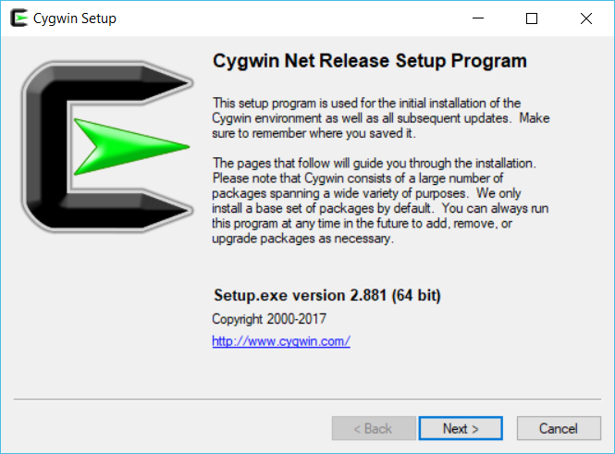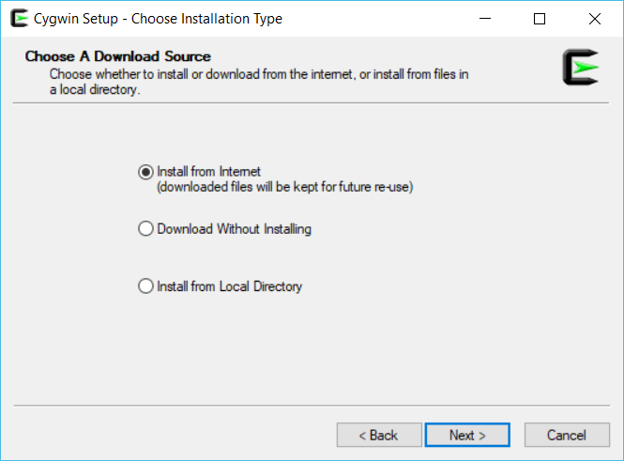

1. Do not change anything, in the root directory, click next

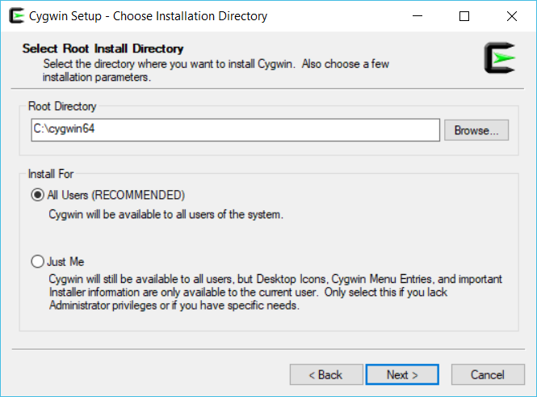

1. For Local Package Directory, choose the drive you want to save in, for this case it saved in my D: / Drive, Click Next, Choose Direct Connection, Click Next

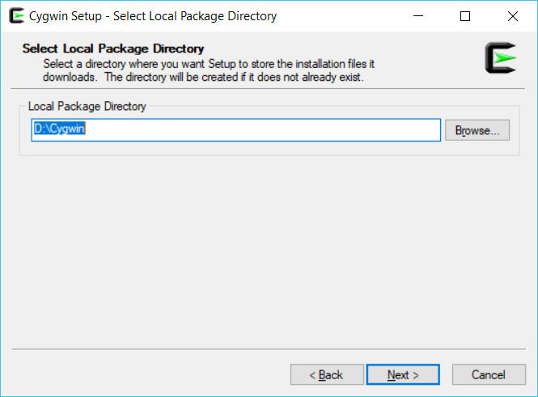 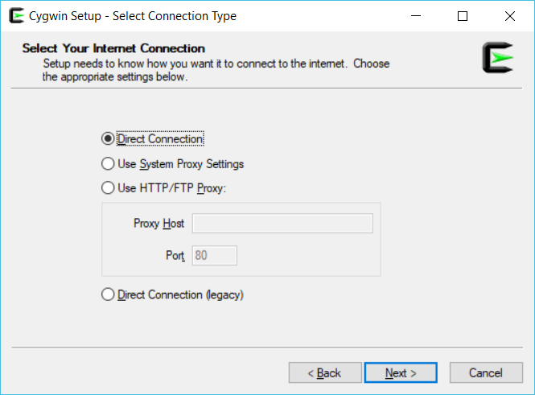

1. Choosing a download site is tricky, it’s a trial and error of choosing a download site, in this case the highlighted website is chosen, then Click Next and wait:

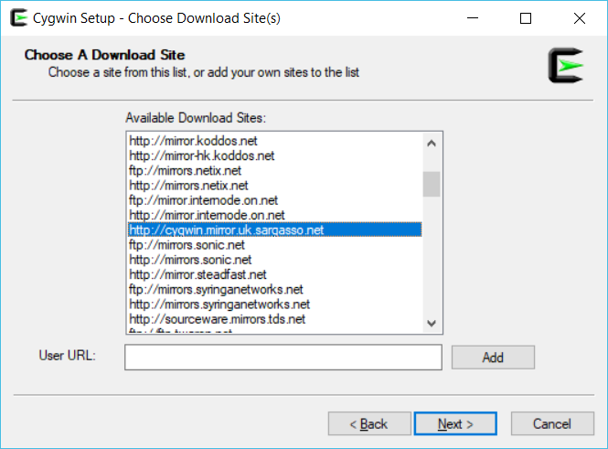

1. Ready for installation of packages:

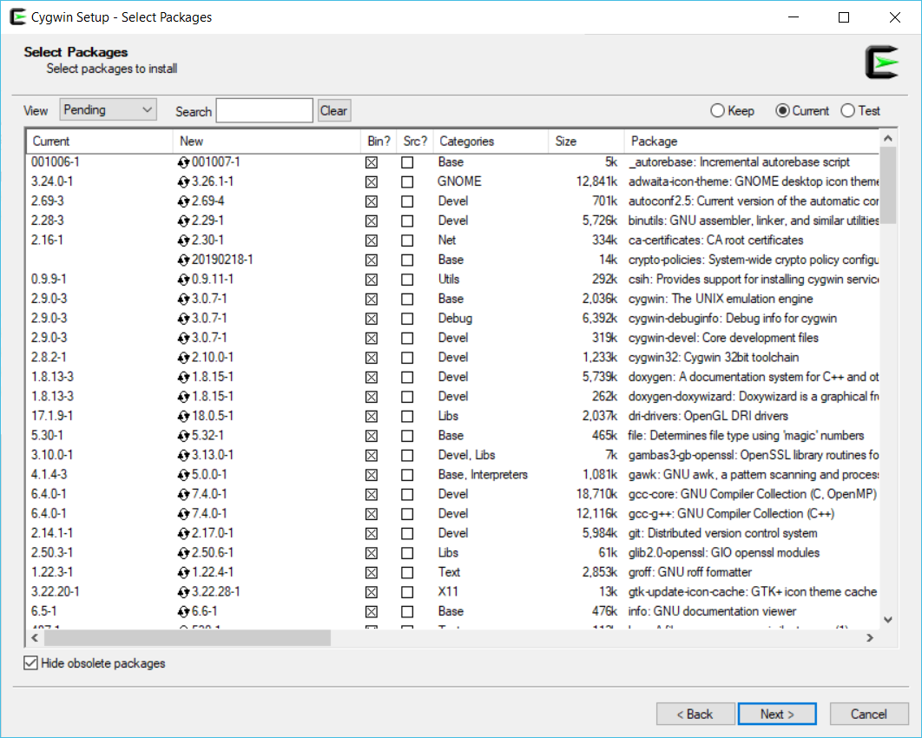

Watch and decide what kind of set up you wanted, this video have lots of additional set up: <https://www.youtube.com/watch?v=Wv7Bs5dRoK8>

Additional Read: <https://www3.ntu.edu.sg/home/ehchua/programming/howto/Cygwin_HowTo.html>

1. Place Cygwin.bat on this folder, this bat is able to compile cl command

